Azure Devops

provides five types of services
i)boards — to create dashboards and to track everything , managing work items
ii)repos —- storing pieces of code in different branches , distributed repos

iii)pipelines - for ci/cd
CI —- developer commit a code to shared repository on regular basis

or when ever the developer commit the code in repos , we need to compile the code and need to generate required artefacts.

cd - when the artefacts are generated in the build pipe line we need to build insfrastructure. on the top of infrastructure deploy the code

iv)test plan - 1)unit test cases , 2)regression test cases —
v)artefacts - to share and maintain packages

build artefacts - when compiling source code
azure artefacts - project reference libraries (dependency artefacts are stored in azure artefacts)

Types:

- Basic
- Agile
- Scrum
- CMMI

Note: Agile and Scrum are most commonly used in real time

TFVC —- team foundation version control (while creating project )
Agent pools

hosted agents

self hosted agents

difference between agent pool and deployment pool ?????????????

azure —- IAAS and PAAS

Azure devops —— SAAS

branches
repos — pending

https://docs.microsoft.com/en-us/azure/devops/boards/work-items/guidance/agile-process-workflow?view=azure-devops

https://docs.microsoft.com/en-us/azure/devops/boards/work-items/guidance/choose-process?view=azure-devops&tabs=basic-process

User stories - incidents

standup call — all team
sprint demo meeting
sprint meeting
back log

branching and merging strategies
git flow
release flow

branch
A branch is an isolated version of the code that you can work on offline without impacting other developers on your team. ... Commit changes to your branch locally. You can keep track of your commit history locally while you work. Push your changes to the remote repository, in the case of this guide, Azure DevOps

GIT Flow -

i)development branch —- latest code
clone the code to local —>we will add changes —>switch this branch from develop to feature

ii)) release branch —- contains old and new features of code

iii)feature branch — implementing changes on top of a existing code

iv)master branch —- production code is present in master branch (backup of production brßanch)
used for production releases

v)hot fix branch —- code from master branch

all the above branches are flow of GIT process.

sonar tube or sonar cloud is used to vulnerabilities , duplicate codes , minor or major issues.

pushing code from feature to dev branch is called merge request or pull request(PR)

——————production branch——————-

——————hot fix———————

——————— Master branch———————(copy of production code)
pull request
———————-release branch—————-

———————— develop branch —————-
pull request —- sonar qube
—————————- feature branch——————

tortoise git — to send code from local to feature

Release flow

- master branch

a)direct from master to production(production will be frozen called as lock)

b)creating tags on master and moving to production

Note: Both the flows described above fall under “REPO Services”
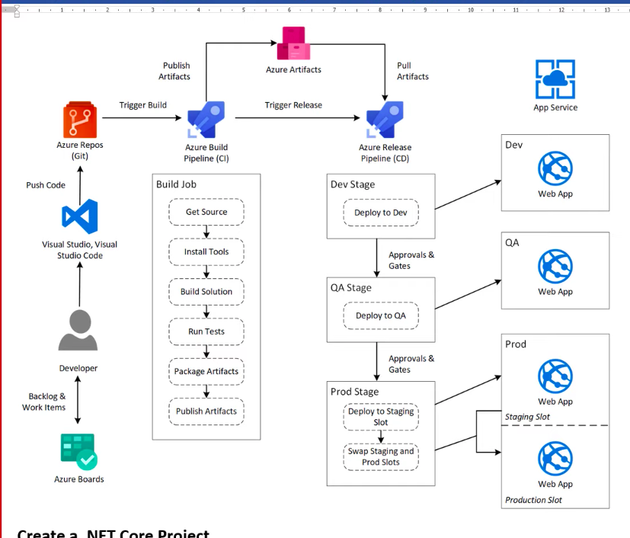

Merging types

- basic merge - it will show history of all commits made in feature branch(D,E) and move them into to main branch by adding an extra dummy branch(here F)
Master —> A - B - C
Feature —->A - B - C - D - E
After PR Master —-> A - B - C - F
D - E`

- Squash merge - it will group the all feature branch commits into one commit then append it in infront of the master branch by adding an extra dummy branch(f)(No commits history)
Master —> A - B - C
Feature —->A - B - C - D - E
After PR Master —-> A - B - C - F

- rebase and fast forward - will append all commits history of the all feature branch in the in front of the master branch , will not add any dummy branch

Master —> A - B - C - F - G
Feature —->A - B - C - D - E
After PR Master —-> A - B - C - F - G - D - E

iv) rebase and merge commit - mix of merge and rebase

Pipelines

its azure service that lets you to build ,test and deploy applications on azure cloud and other supported platforms.

i)platform and language independent
ii)freedom to work with containers
iii)deployment to other cloud vendors
iv)support for open source

Azure Pipelines automatically builds and tests code projects to make them available to others. It works with just about any language or project type. Azure Pipelines combines continuous integration (CI) and continuous delivery (CD) to constantly and consistently test and build your code and ship it to any target.

2 types of pipelines
i) Yaml - stored in the form of yml code. stored in repos. it has multiple stages such as build and release(both will be performed in single stage)
we can deploy condition based pipelines.
ii)class c - graphical representation.here the build stage and release stages are performed separately.

language build tool

java ——— maven
.net ——— MS build
.net core —— .net
angular js —— NPM

here We have used MS build to compile, build and to generate artefacts of a source code.

creating pipeline

selecting agent

agent is used to build to compile, build and to generate artefacts of a source code.

agent will be created on remote server
class - 23
hosted agents — managed by micro soft. naming convention is azure pipeline
self hosted agent —- installing required softwares

build configurations
i)debug
ii)release

platform — any cpu

creating self hosted
- project settings —>go tp agent pools —> create agent pool
- select self hosted agent poo , check pipeline option as grant access to all pipelines
- go to created self hosted agent and click on download(select os accordingly windows or macOS)
- downloaded file need to be extracted and installed in vm that need to be made as agent
- click on server url - devops url(till project)
- PAT(personal access token
- give the working folder
- once you goto agents in devops portal the agent will be in offline mode. so click on run file or enable the agent service in services.msc

What happens in agent when you run pipeline
- Work folder will be created
- under working folder
i) tasks folder( tasks that are used in pipeline)
ii)tool folder( tools eg nugget tool)
iii) 1 folder and under 1 folder
i) a —Build.ArtifactStagingDirectory
The local path on the agent where any artifacts are copied to before being pushed to their destination. For example: c:\agent_work\1\a

ii)b — Build.BinariesDirectory
The local path on the agent you can use as an output folder for compiled binaries.

By default, new build pipelines are not set up to clean this directory. You can define your build to clean it up on the Repository tab.

For example: c:\agent_work\1\b.
iii)s — Build.Repository.LocalPath
The local path on the agent where your source code files are downloaded. For example: c:\agent_work\1\s

Library —- variables values will be stored.

predefined variables — defined by microsoft
pipeline variables — variables used in within the pipeline
variables group— variables used in group of pipelines

Builds

Gated build — after raising a PR to pass code from feature to dev then gated build will run. here we do quality check.

continuous integration — after the PR completed CI will run. Artefacts will generate.

while creating the pipeline, artefacts will be created. these artefacts are used to deploy the code. Along with artefacts , stages are also created.

scheduled build

releases - generated artefacts will be released.

task group - re usable tasks will be grouped together.

deployment groups - here the code is build and deployed there it self. mostly for vm’s.

